ADVANCED SOFTWARE ENGINEERING

SWINNEY GENNIE

Sirisha Pakalapati (16161825)

SreeVishnu Satarajupalli(16162426)

SriHarsha Veerepalli(16149284)

Prakash Garapati(16165267)

Under the guidance of

Prof. Yugjung Lee

TA: Fiechen Chen

**INDEX**

Project Deployment 0-1

Project Management 2-7

User Manual 8-13

Project (Pre) Proposal 13-14

Project Proposal & Plan 15-22

First Increment 23-28

Second Increment 29-30

Third Increment 31-34

Fourth Increment 35-40

**SWINNEY GENNIE**

[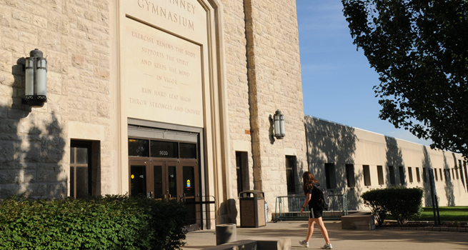](http://www.google.com/url?sa=i&rct=j&q=&esrc=s&frm=1&source=images&cd=&cad=rja&uact=8&docid=4dafdSx8qQ_60M&tbnid=w62gLTAEufzreM:&ved=0CAUQjRw&url=http://www.umkc.edu/virtualtour/swinney-rec.asp&ei=KbZzU7--H5CPqgb3yILoDw&psig=AFQjCNFC0RJmltkZ2Knz1KnuKeSOhbNzqw&ust=1400178597525610)

Video URL: [https://www.youtube.com/watch?v=9f7jHaaxet0&feature=youtu.be&hd=1](https://www.google.com/url?q=https://www.youtube.com/watch%3Fv%3D9f7jHaaxet0%26feature%3Dyoutu.be%26hd%3D1&usd=2&usg=ALhdy29rrP7YujnXOscxAZJcLeLRhYb2wQ)

Github URL: <https://github.com/sshy3/Finalprjct>

Scrum do URL: [https://www.scrumdo.com/subscription/expired/ase6/staff](https://www.google.com/url?q=https://www.scrumdo.com/subscription/expired/ase6/staff&usd=2&usg=ALhdy2-VAnBcXqjM_Leyx51x2QNkfqFCGQ)

**PROJECT MANAGEMENT**

**Project management report:**

**Scrum do:**

Agile website is a great website for project management purpose. We can manage our tasks and assign tasks to each group member and track work done by each group member easy through the agile website scrum do. The below are the screen shots of all iterations.

For first Iteration, we mainly focused on Interfaces. I.e. Admin and User interface.

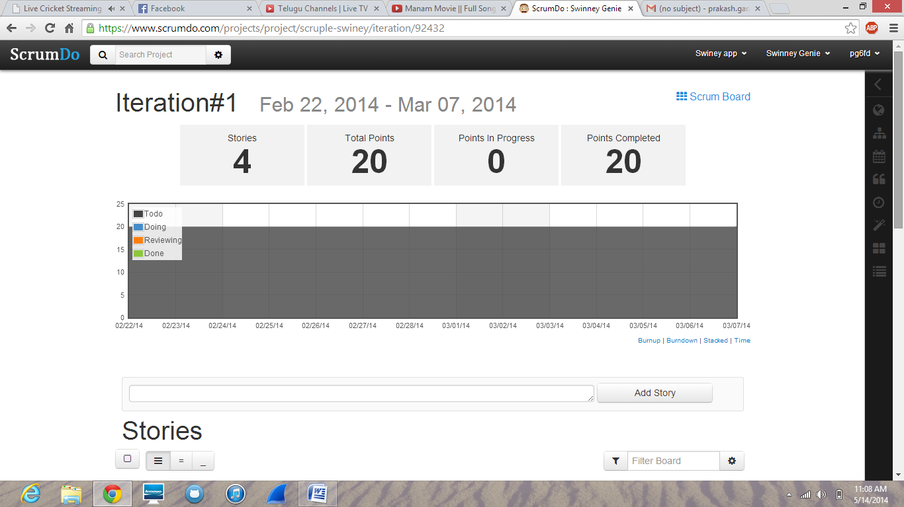

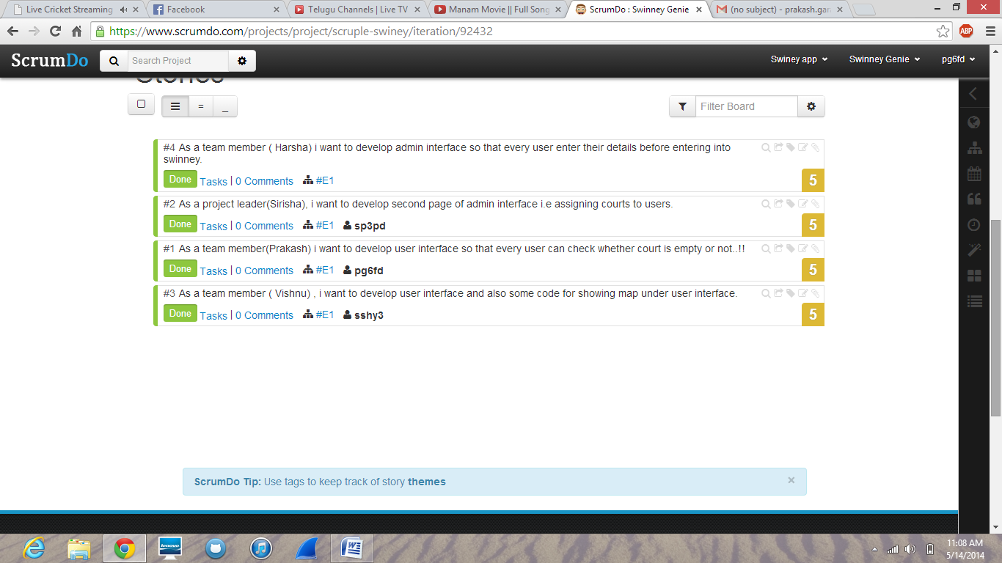

For second iteration, we focused on user interface i.e. showing details court and items…

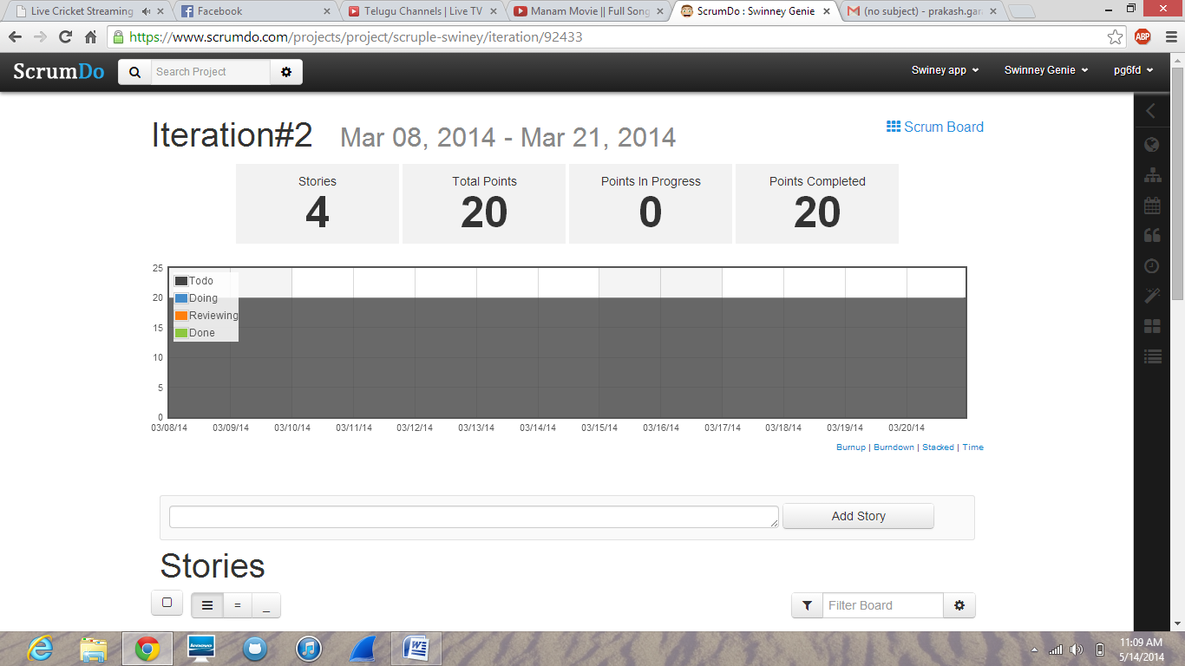

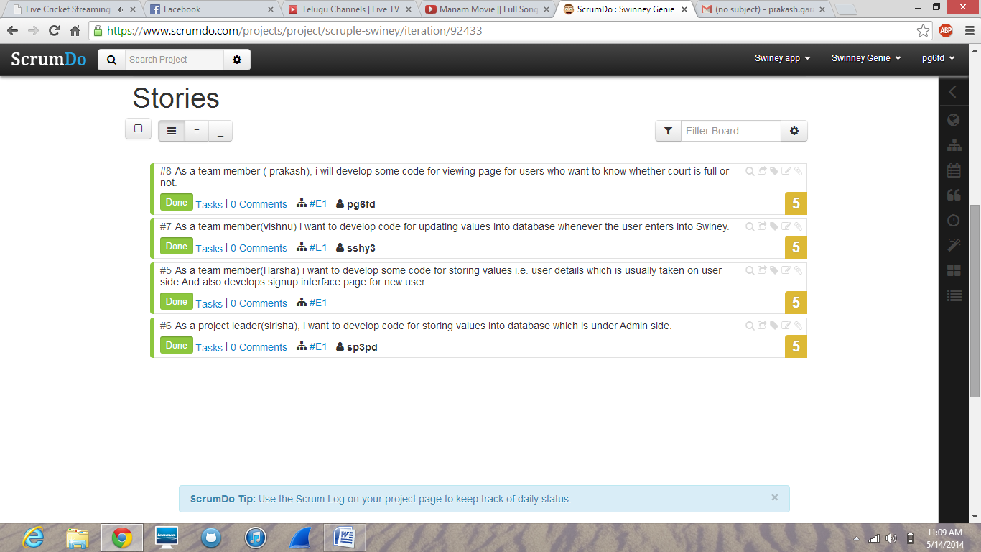

For third Iteration, we focused on database connections…. i.e. retrieving values from database.

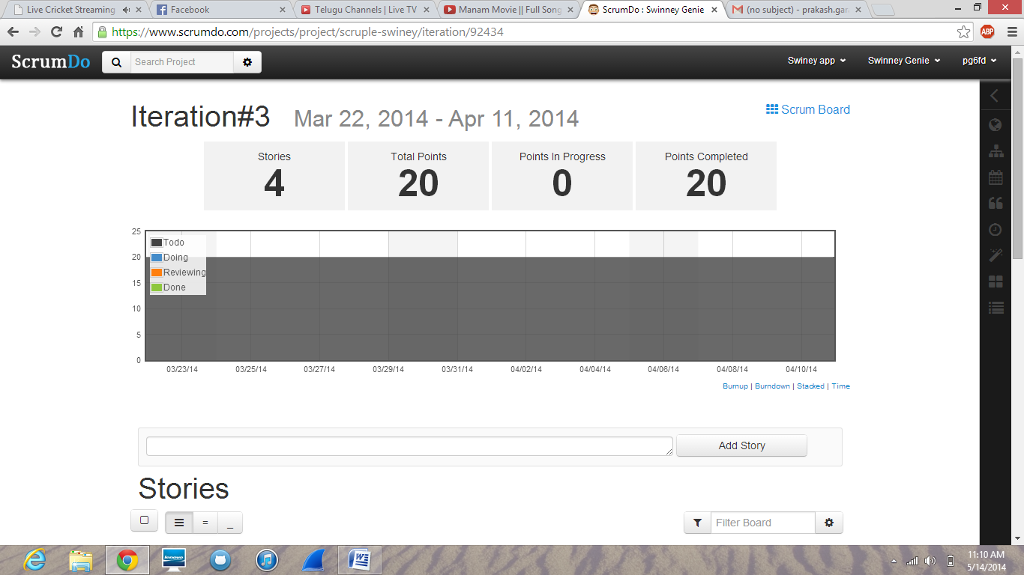

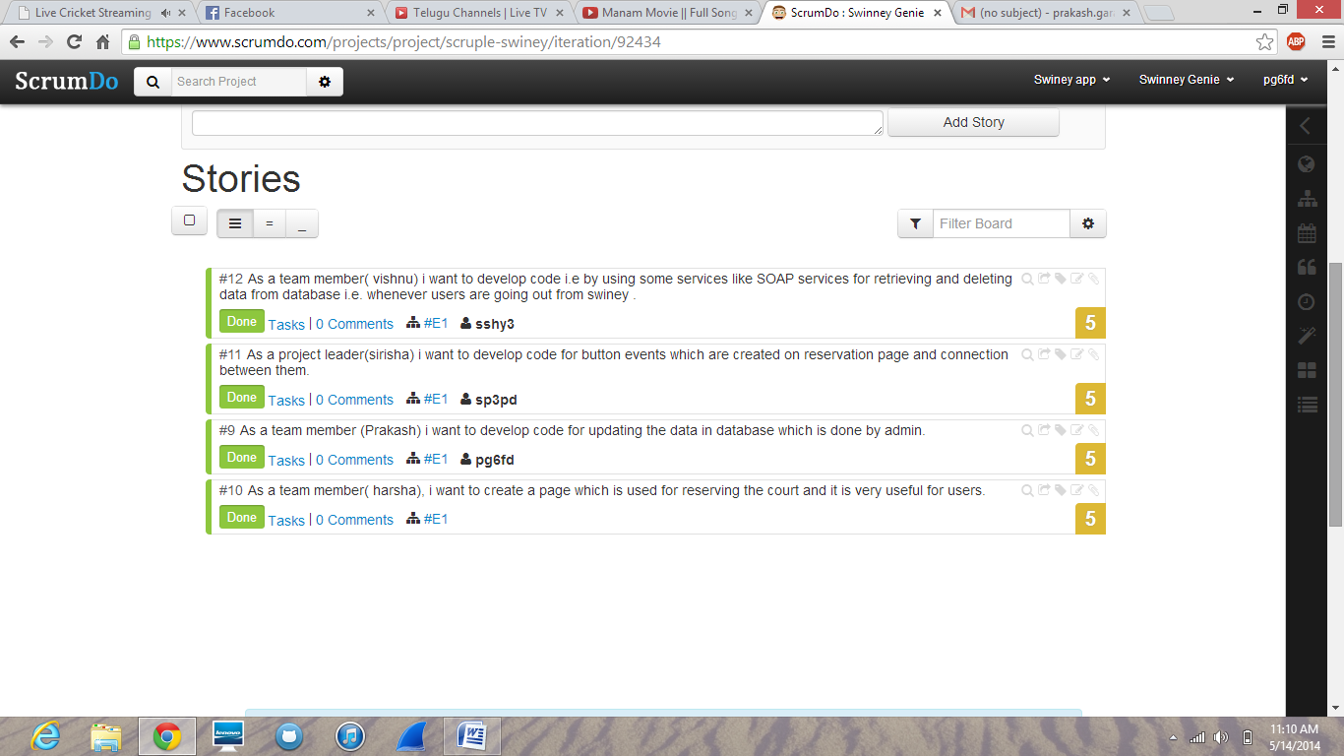

For last iteration, we developed on Admin interface and web services like SOAP to access the values

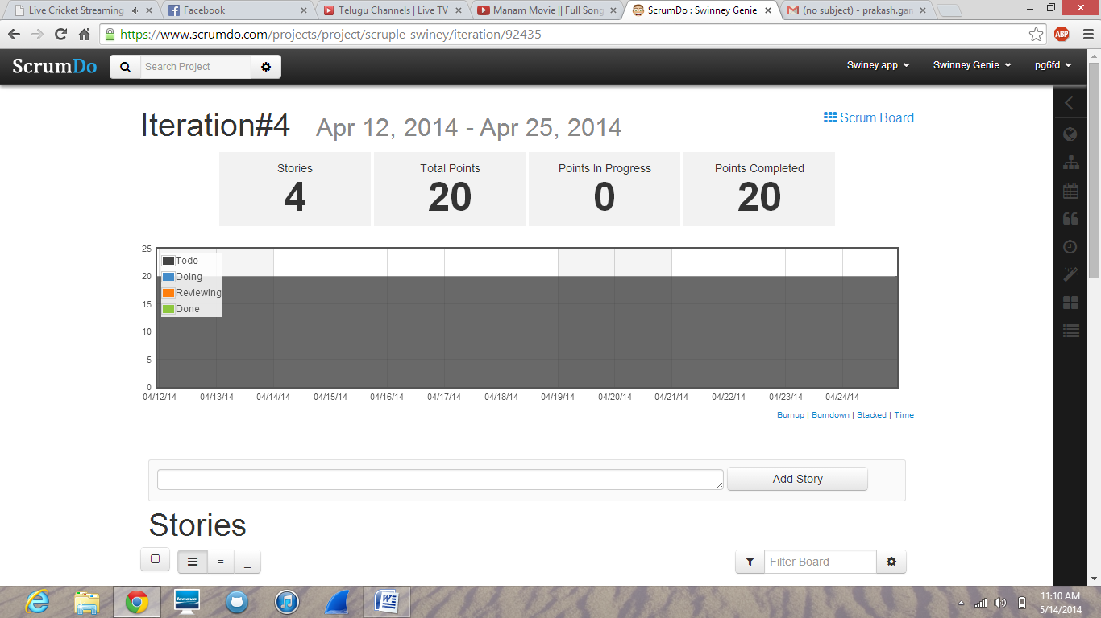

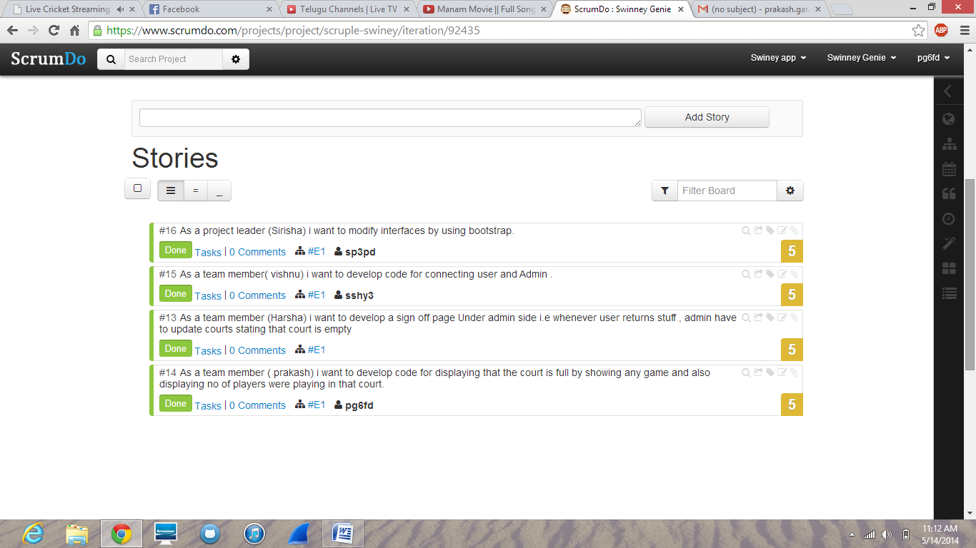

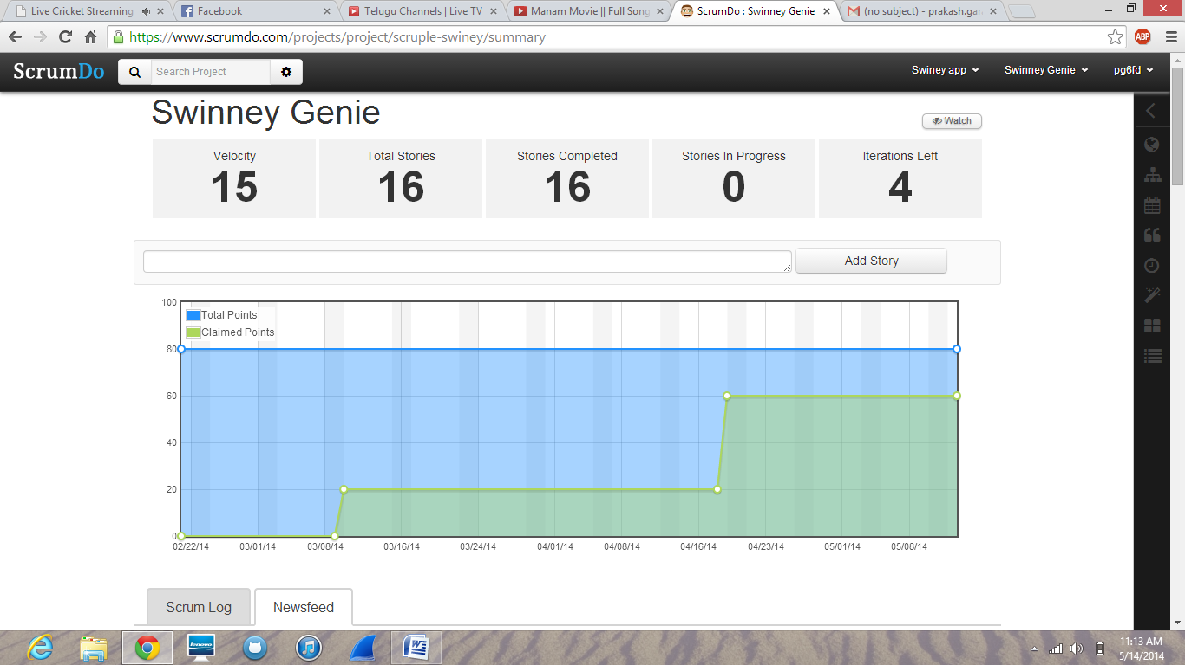

* **Scrumdo Link**: https://www.scrumdo.com/organization/ase6/dashboard

**Final project evaluation:** The project was developed in four increments. This was according to the agile development process. All the project progress was recorded in the scrum do tool. For this project we have shared our work among four members at the starting and everyone has succeeded in fulfilling their tasks at the right time equally. We didn’t get any problems or difficulties in fulfilling our tasks. As the modules of the project doesn’t depend upon one another we were successfully able to use the agile process. If a project with modules depend upon one another agile process would not be helpful. We have met the deadlines what we have kept for all the increments in our scrum do except second increment where we have struck up with rest services.

**USER MANUAL**

**Introduction:** As we all know that in Swinney Recreation Center, we play many games like badminton, basketball, football etc... The main problem over here is at times people get vexed up to play there due to few reasons like there may be no place in the court i.e. the courts may be already filled up or there are no available playing stuff.

So our main motto, is to develop an application on Swinney Recreation Center, to check the availability of courts i.e. whether the courts are filled or not and also to check the availability of badminton Racquets and basket ball's all different playing stuff.

**How to use our Swinney Gennie:** Users can open this application in computer or can open in mobile using a browser. Admin can open only in computer that too only in the campus.

**Error recognition and handling:** We have first developed our interfaces in bootstrap and then imported it into visual studio which led to many compilation errors and compatibility issues, where we have resolved the errors by changing everything where we are getting errors to asp.net language.

**Sample Example:**

**Here we have two interfaces**

1. **Student interface**
2. **Admin interface**

**Student interface:** The student has to login with his credentials i.e.; umkc ssoid and password.

Home page:

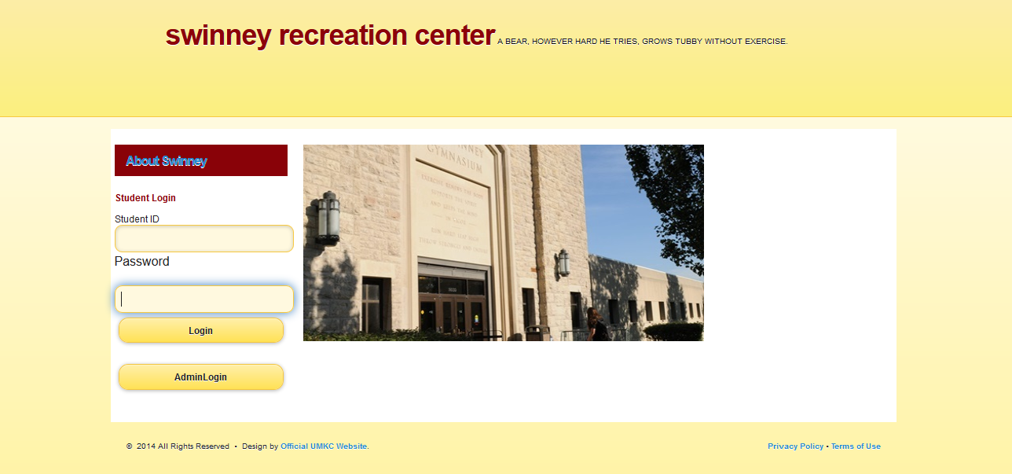

**You can enter your student details and can login:**

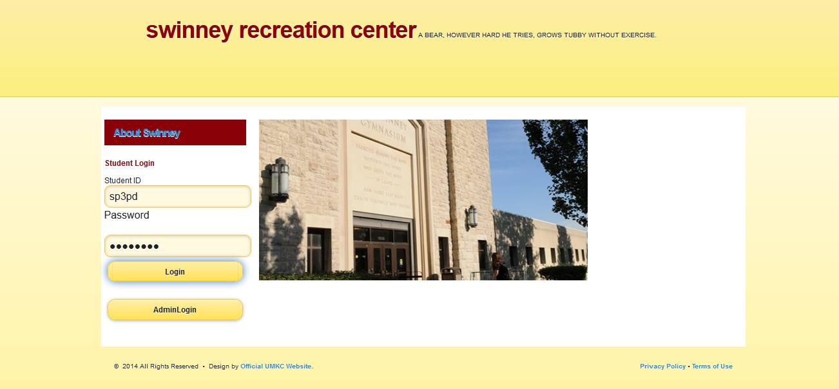

**You will be redirected to a page where you can see what all the available items in the swinney for playing and the court details i.e. how many players in the court**

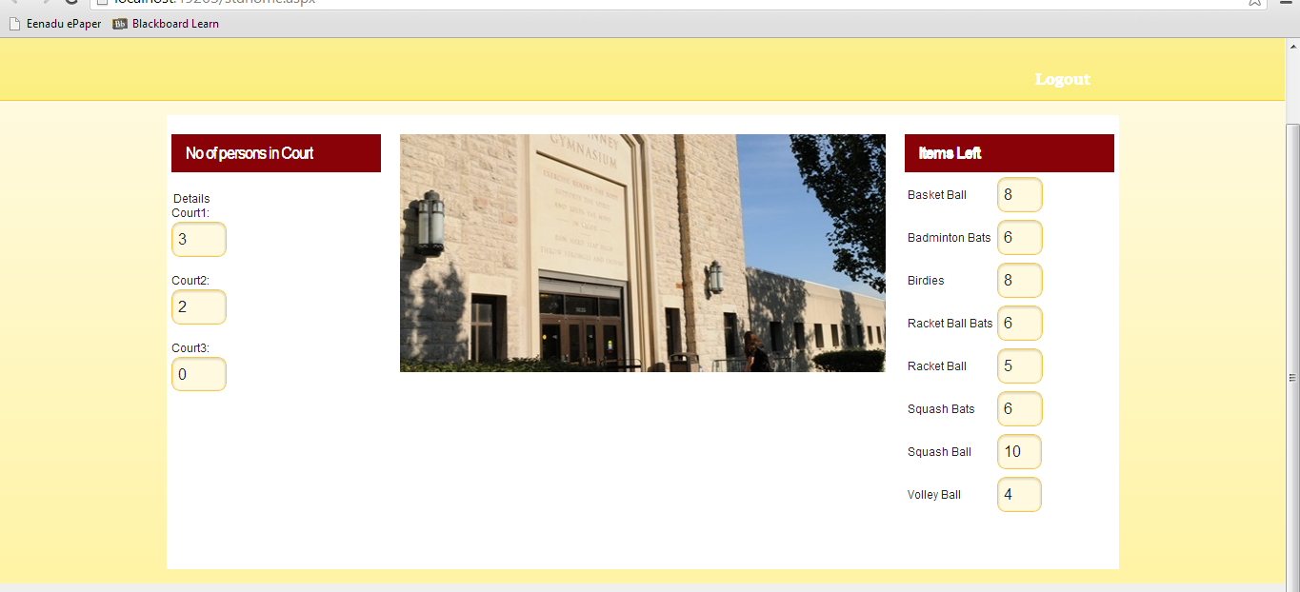

**Here a student can see what all the available items and he can decide whether to go to swinney or not for playing which can reduce the wastage of energy and wastage of time.**

**Admin Interface:**

**Admin has to enter his credentials for logging in he will get a page where he can checks in the items which are selected by a particular student.**

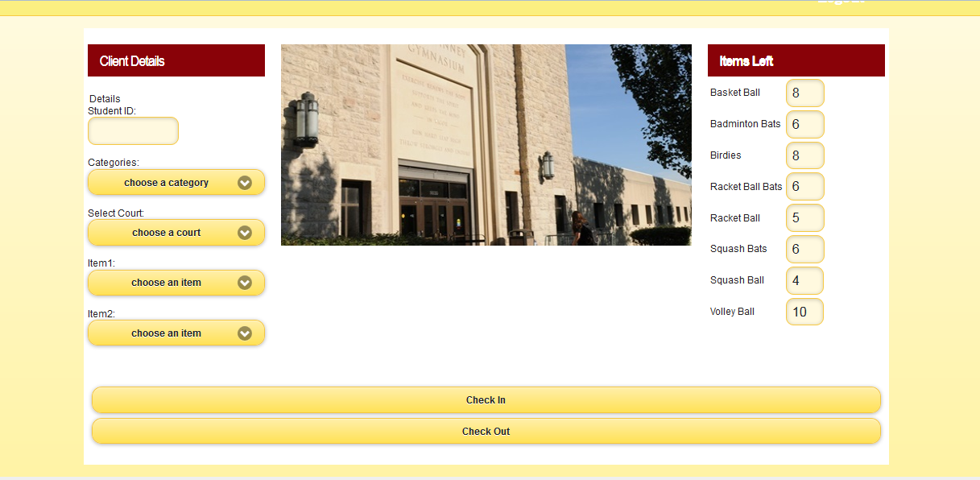

**Entering the student details:**

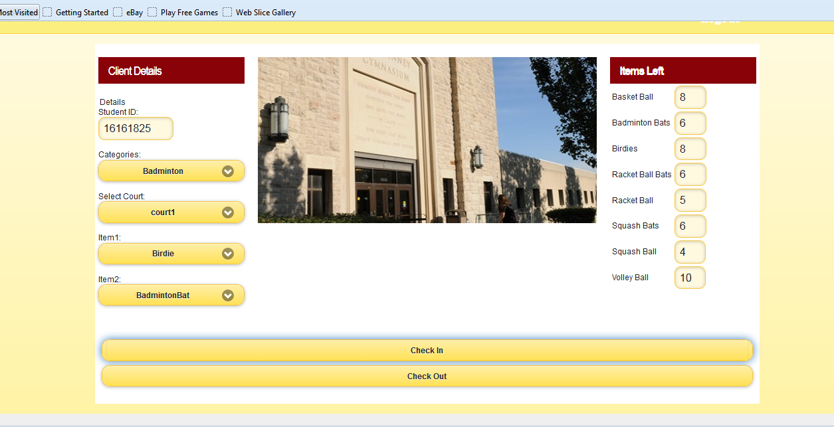

**When he clicks on check in he will get the following page:**

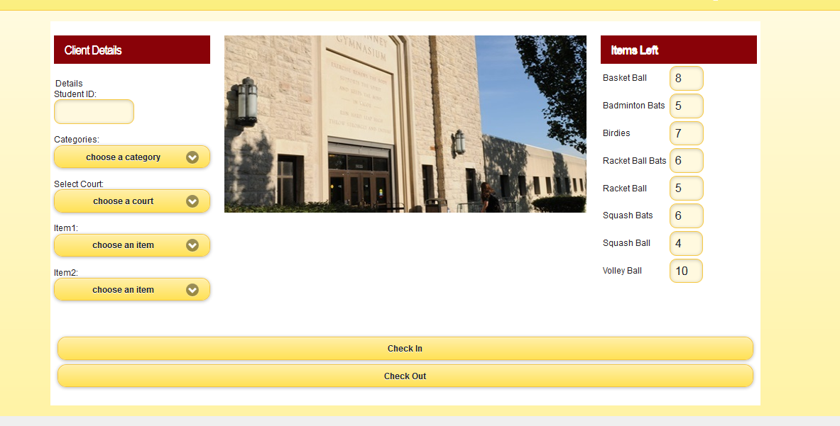

**When the student comes for the checkout, the admin enters the particular student id of that student and then he clicks checkout.**

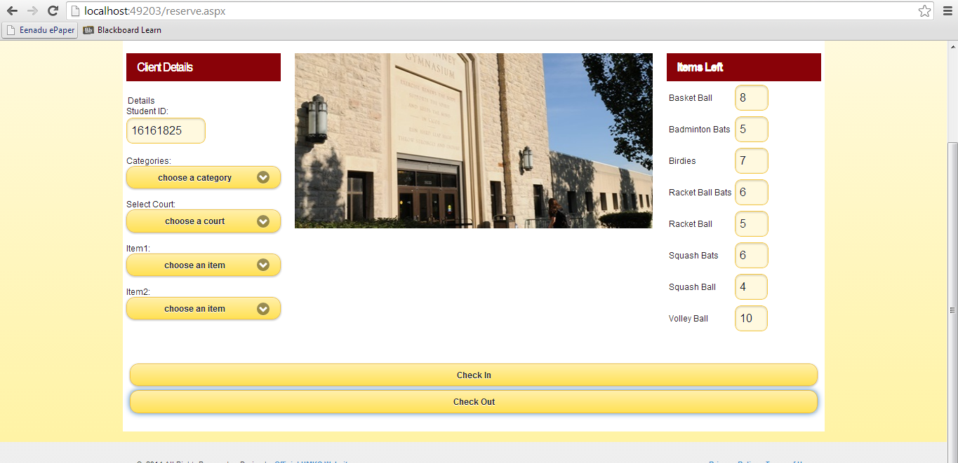

**Now he will get the following screen by checking out all the items taken by that particular id of that student.**

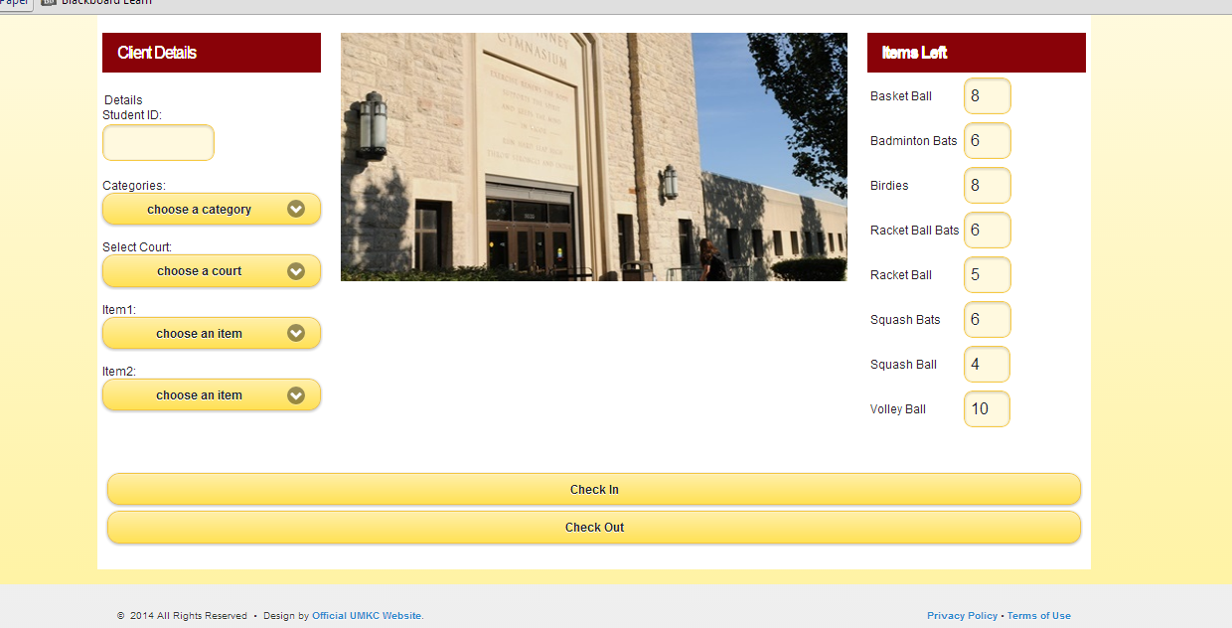

**When the student or Admin logs out, he will get the following screen ie: home page:**



**When the courts or the items are not available the student will be getting an email to his umkc mail indicating that the courts are available from the admin:**

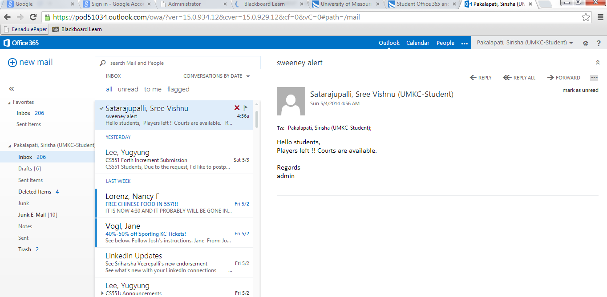

**A list of known bugs and deficiencies:** As per our knowledge our app doesn’t have any bugs or deficiencies.

**Swinney App Proposal:**

**Motivation:**

As we all know that in Swinney Recreation Center, we play many games like badminton, basketball, football etc... The main problem over here is at times people get vexed up to play there due to few reasons like there may be no place in the court i.e. the courts may be already filled up or there are no available playing stuff.

So **our main motto, is to develop an application on Swinney Recreation Center**, to check the availability of courts i.e. whether the courts are filled or not and also to check the availability of badminton Racquets and basket ball's.. All different playing stuff.

**Significance:**

This application is very useful and we can use it in Real time. The college management has already developed some apps, but with that we can know only the timings of swiney. So our main significance to develop this app is to check a court i.e. whether it is occupied or not. By using that application we can save time and energy. Swinney is run on a first come, first serve basis i.e. whoever comes first, the court will be occupied by him and it will be excruciating to people who came at last, so at this scenario our app will be very useful.

**Objectives:**

The main objective of our project is to satisfy people without wasting their valuable time. By using this app we can know whether the courts are occupied or not.. And this in turn saves more energy. In this project, we will have an admin and he should take all the login details of students who are entering into the Swinney and to which place they are heading to i.e. for badminton or basketball etc. The same admin will also be held responsible for check in items i.e. giving badminton racquets and basketball etc. Each user (Student) has to check out all items while they are going. After entering login details, the admin has to mark the court in the system as the court is filled so that the students can know the court is filled by using the app from wherever they are. After check out, admin has to unmark it so that the people can know the court is vacant now.

**Proposal and Plan:**

**Introduction:** As we all know that in Swinney Recreation Center, we play many games like badminton, basketball, football etc... The main problem over here is at times people get vexed up to play there due to few reasons like there may be no place in the court i.e. the courts may be already filled up or there are no available playing stuff.

So **our main motto, is to develop an application on Swinney Recreation Center**, to check the availability of courts i.e. whether the courts are filled or not and also to check the availability of badminton Racquets and basket ball's all different playing stuff.

**Project Goal and Objectives**

* **Overall Goal:**

Our overall goal is to create a mobile application for Swinney recreation center of UMKC which serves the purpose of reserving the courts and finding the availability of the playing stuff and finding when the courts will be available free so that they can come at that time for playing.

* **Specific Objectives(Problem Statement):**

The main objective of our project is to help people without wasting their valuable time. By using this app we can know whether the courts are occupied or not. And this in turn saves more energy. In this project, we will have an admin and he should take all the login details of students who are entering into the Swinney and to which place they are heading to i.e. for badminton or basketball etc. The same admin will also be held responsible for check in items i.e. giving badminton racquets and basketball etc. Each user (Student) has to check out all items while they are going. After entering login details, the admin has to mark the court in the system as the court is filled so that the students can know the court is filled by using the app from wherever they are. After check out, admin has to unmark it so that the people can know the court is vacant now.

* **Significance:**

This application is very useful as we can use it in Real time. The college management has already developed some apps, but with that we can know only the timings of swinney. So our main significance to develop this app is to check a court i.e. whether it is occupied or not. By using that application we can save time and energy. Swinney is based on a first come first serve i.e. whoever comes first will have the court occupied if the court is available and it will be excruciating to people who came at last, so at this scenario our app will be very useful.

**Project Background and Related Work**

* **Work done by Others:**

Many applications are based on the reservation and checking of the available stuff. All these applications are mainly for the use of a single person gives the results according to the user only. But this application takes into account all the students of UMKC and helps in reserving the courts of the Swinney Recreation center and finding the available playing items.

The Application we have planned to develop is different from all other applications in the following ways:

1. It provides the availability of the courts in the Swinney recreation center.

2. The student who wants to know the information about courts and playing items has to first join into our application by creating a username and password.

**4. Proposed System**

4.1. Requirement Specification

Functional Requirements:

* Users have to first register by entering their first name, last name, student id, email id and password.
* All the information about the playing stuff is there in the website.
* Users will get notifications about any game events are held in UMKC.
* Users can select the particular game he is interested in.
* While entering into the profile of the game we will get the availability of the courts and availability of the playing of that game and we will get the information about when the court will be free.
* Users can reserve the courts and playing stuff when available free, in the website.
* Users can like the application and post on Facebook and tweet on twitter.

Non Functional Requirements

* The application must give results pertinent to the preferences set.
* The application should give results as fast as possible without any lag.
* The user interface should be user friendly.

Business Requirements

* System: The system should return results as fast as possible without any delay.
* User: All the users want the results which satisfy every member of the group.

Business/Domain Model:

Domain Model consists of major classes in the basic management of the project. It includes all the crucial abstractions of the business environment. It is like the building block of the project.

Technological and Architectural Requirements:

Technological requirements we need HTML JavaScript, CSS for the user interface. AJAX is also used to avoid total rendering of a page after any postback. We need the information about the total no courts and playing stuff available in the Swinney. Architectural requirements include browser which can open the web application.

**4.2 Framework Specification (to be done : interface)**

**4.2.1 Assumptions and Principles**:

The users are assumed to have mobile or compatible browsers to view the web pages. The user creates an account with their name and password.

The principle used here is updating the information about the courts and the playing items when they are returned to the front desk.

**4.2.1Methodologies and Algorithms**:

The algorithm used here in this application is first in first out scheduling algorithm where the user who comes logs in first and who reserves first gets the court reserved.

**4.2.4 System Architecture Diagram**:

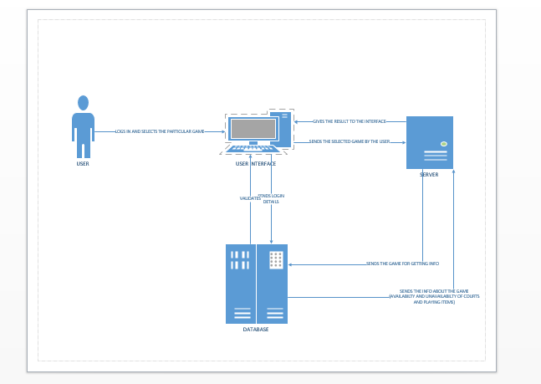

**3) SYSTEM SPECIFICATION:**

* **NEW SERVICES TO BE BUILT**: We are building a Mobile application in which any student can reserve the courts and playing stuff in Swinney recreation center and can view the information about at what time the courts and playing stuff will be free so that they can reserve.
* **CLASSDIAGRAM**: 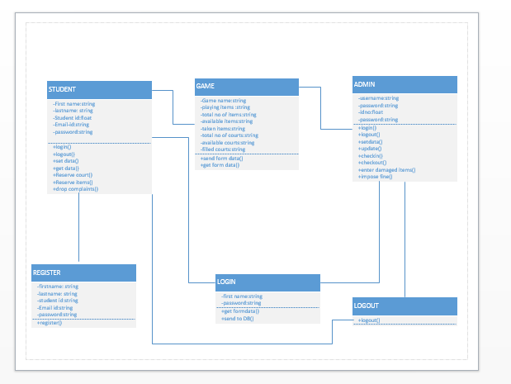
* **SEQUENCEDIAGRAM**: 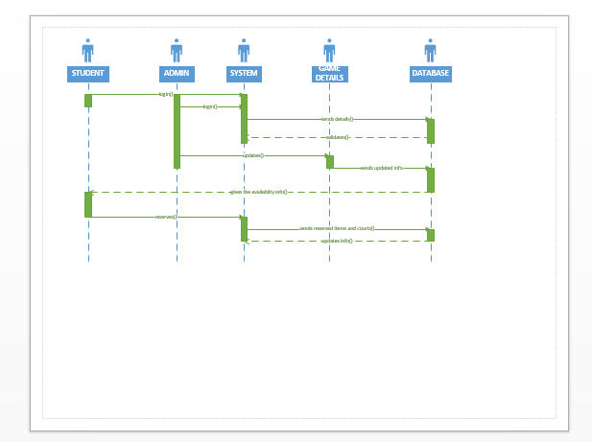

**SERVICE SPECIFICATION**:

**Operational description**:

**Input for services**: In our application input is the data entered by the user.

**Output for services**: In our application output will be the list of courts and items of games available for available for playing

**Constraints:** The students who are not enrolled in UMKC cannot have access to this Application.

**Exceptions:**

**Service flow:** Here in this application after the student logs in he has to choose the particular game he is interested in and it goes to the database and the database sends the information of the available courts and playing items to the user.

**Priorities**:

1) Processing is the main priority in our application.

2) Preference of the student ie; game he/she is interested in is also the priority in our application.

**DESIGN OF MOBILE CLIENT:**

**Features:** submit button, Login button, save button

**Styles:**  CSS

**Technologies**: HTML

JavaScript

Jquery Scripting

IBM smart cloud

SQL or MYSQL

**V) Project Timelines, Members, Task Responsibility:**

**First Increment**: As for the first increment, we want to install all software’s like Visual Studio etc. and tools required for "SWINNEY GENIE” project. Then we want to create the sign in page for users who want to see whether courts are full or not and also develops admin interface page for the users who are entering into swiney so the Timeline is MAR 07.

**Second Increment**: For this increment, we want to develop a code for storing values into database and also checking the details of user whether it is correct or not. Also develops a sign up page for new users who want to see whether court is full or not. So the Timeline is MAR 21.

**Third Increment:**  In third increment we will concentrate more on user interface i.e. by showing the entire map of swiney. Whenever user wants to check court, he/she just clicks on that map then it will shows by displaying some game and also develops code for button clicking events to show that map. We also want to create signup page for users and also uses the services like GET method to update values into database. For this increment the timeline is APR 11th.

**Fourth Increment**: In the final phase of project, we want to connect all interfaces and we want to deploy the entire project into IIS server.

**Vi) RISK MANAGEMENT**:

* Risks in a project are identified and generally they can be resolved by using some efficient methods. Minor risks involved in our project are:
* Users may forget their passwords.

**Vii Hosting**

All the work is posted to the github including project plan document and the link is:

Scrum Do link is posted to the link given.

Web Client is to be Developed in 1st increment.

**Viii BIBLIOGRAPHY:**

1. <http://www.umkc.edu/src/>

**First Increment:**

**Existing Services/API:**

No existing services or API were used as the project we are developing is requires services which are new and no existing services provides these. All the source code and services are written and implemented in C# using visual studio. The interface was developed using HTML5, CSS, Jquery and Jquery Mobile.

**Design of Services:**

* ***Stories (Scrum Do):***For First increment, we developed user and Admin interfaces. In this period we developed login page for user and page for admin to note down the details of user before entering into swinney and also we developed a page for user to check whether court is empty or not.
* ***WSDL (Service Description****):* Two services would be used in the project. One is to store the student check in data which includes the game or court he is going to, the list of items he is playing.And when the student is getting out of the Swinney his data is to be cleared. This is done by updating the database through the service. This is done by the admin. service would be getting the stored data in the database by the push service. The data retrieved is displayed accordingly in the interface to the user.
* ***SequenceDiagram****:*
* *ClassDiagram:*
* ***Design of Mobile Client Interface:***

Two separate interfaces were developed one for the user and one for the admin. The respective persons can select their interface from the Home page designed giving the brief details of the Swinney Recreational center.

**User Interface** has gives the details of the user, has the map of Swinney which displays the number of courts and the players playing on it. It also displays the items left individually. The user has been provided with a logout button to exit the system.

**Admin Interface**logins into his interface through the login page provided. After logging in ithas the input box to enter the students IDs who enter into the Swinney. The admin can select the game he chooses and court he goes to and the item he chooses through the drop down menu provided. After selecting this the admin has given a check in button to the save the preferences to into the database.The interface has also a checkout button to check out the student who leaves the Swinney. The admin page has provided with logout button to exit the system.

* ***Design of Unit test Cases(using Nunit tool):***

As there are three services in our project storing the data, delete the data and retrieve the data. Each service is tested individually using Nunit testing tool using the Assert.AreEqual function and depending the type of the service used. (Rest or Soap).

**IMPLEMENTATION:**

**Implementation of Services**:

In this project, we want to use "C#" visual studio for implementation of web application i.e. Swinney Genie. For this we use web service application which is installed in C#. After the completion of successful running of app on web, then we want to deploy it on IIS server.

**Implementation of User Interface:**

The user interface is implemented by using HTML, Jquery, Twitter Bootstrap and Css. In our project we developed two interfaces one is" ADMIN interface" and another one is" USER interface". The following are the screen shots of both interfaces.

The screenshot here gives the Home Page of the Project which has the user login as seen.

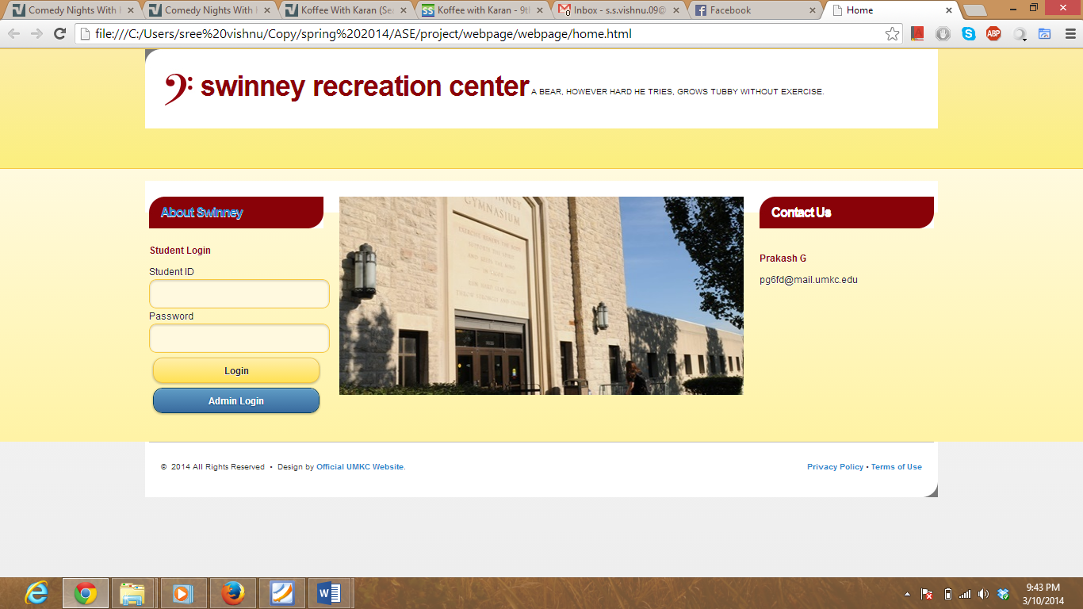

The following is the screen shot of Admin Login.

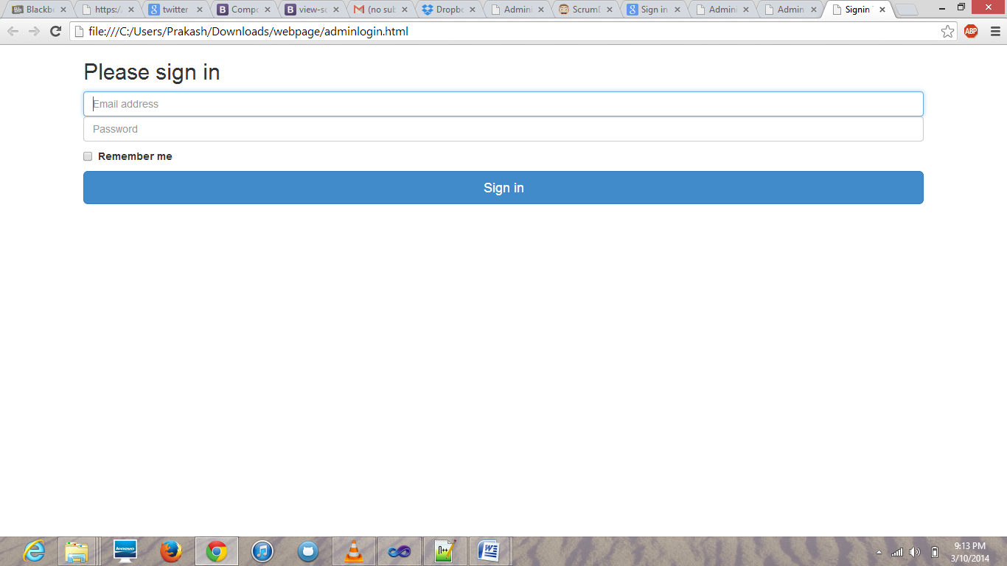

The following is the screen shot for admin to enter details of user Before entering into swinney.

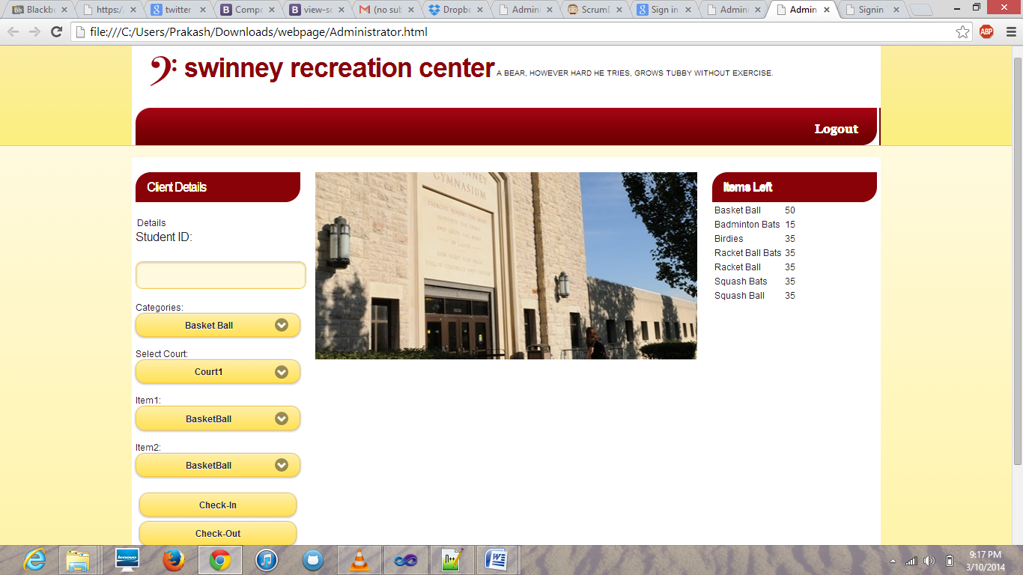

The following is the screen shot for user to check whether court is empty or not....

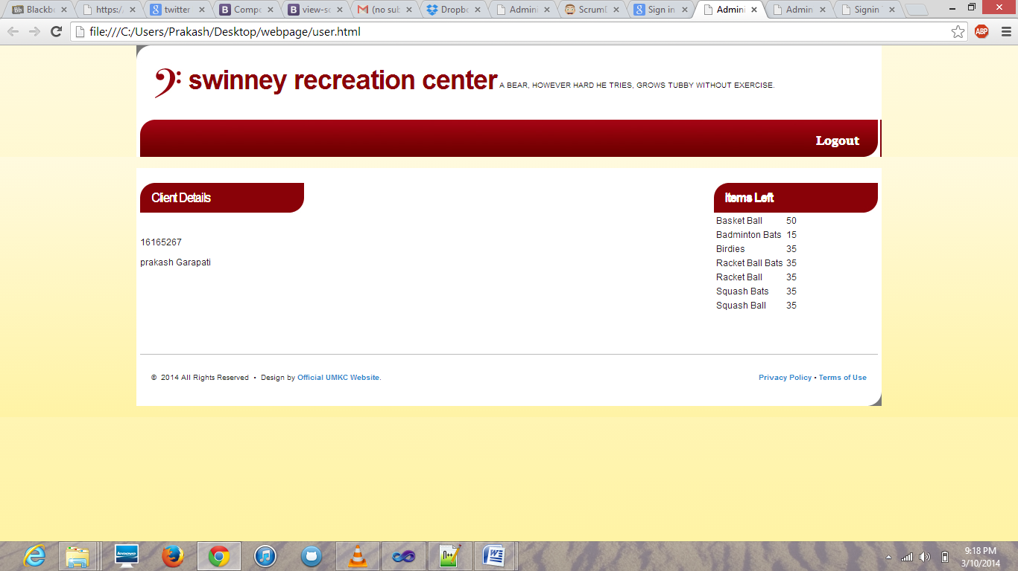

The following is the screen shot of scrum do story , when work is in ToDo condition.

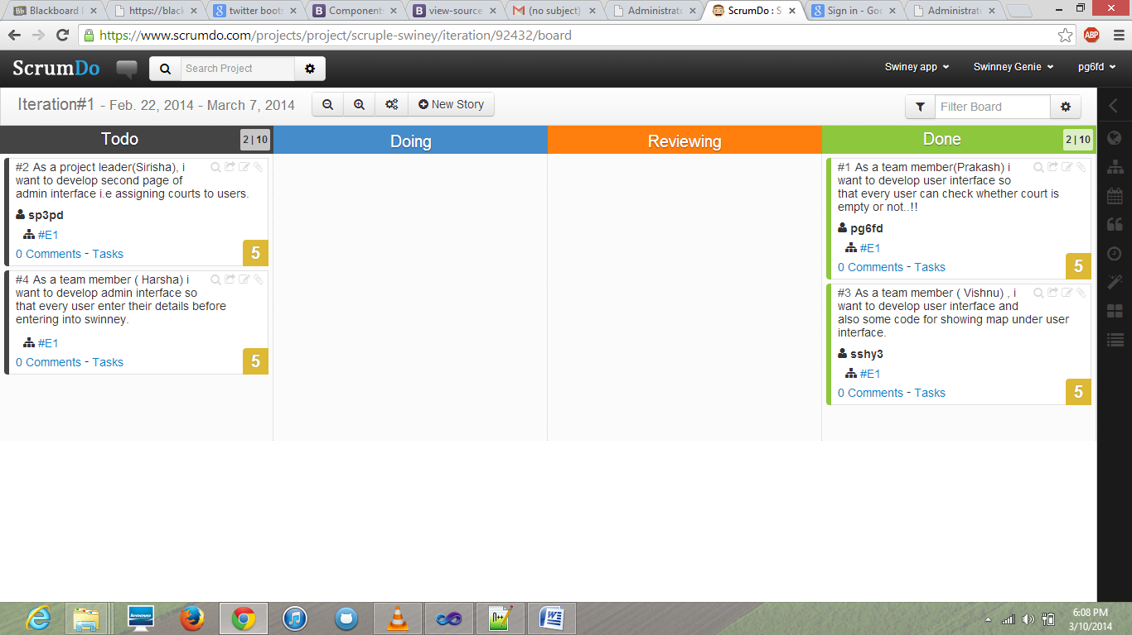

The following is the screen shot when the work is in done condition.

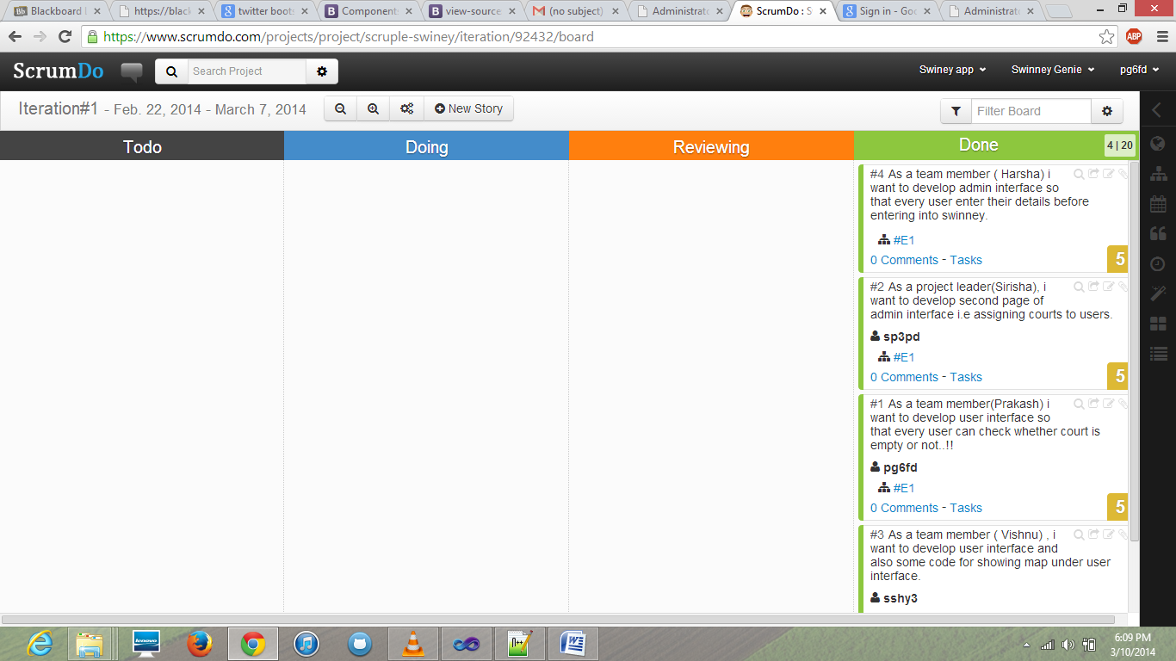

**Implementation of Testing:**

Each module of the total project is tested using Nunit testing tool as C# is used to develop the services. As the services are still in the development stage performing the testing is not possible.

**Second Increment:**

Services were written in visual basic 2013 in the service.svc file of the WCF application. Required Databases were added to and queries were written in the services to access the Databases. The services thus written are consumed from the client through HTML and Javascript. This can be shown below:

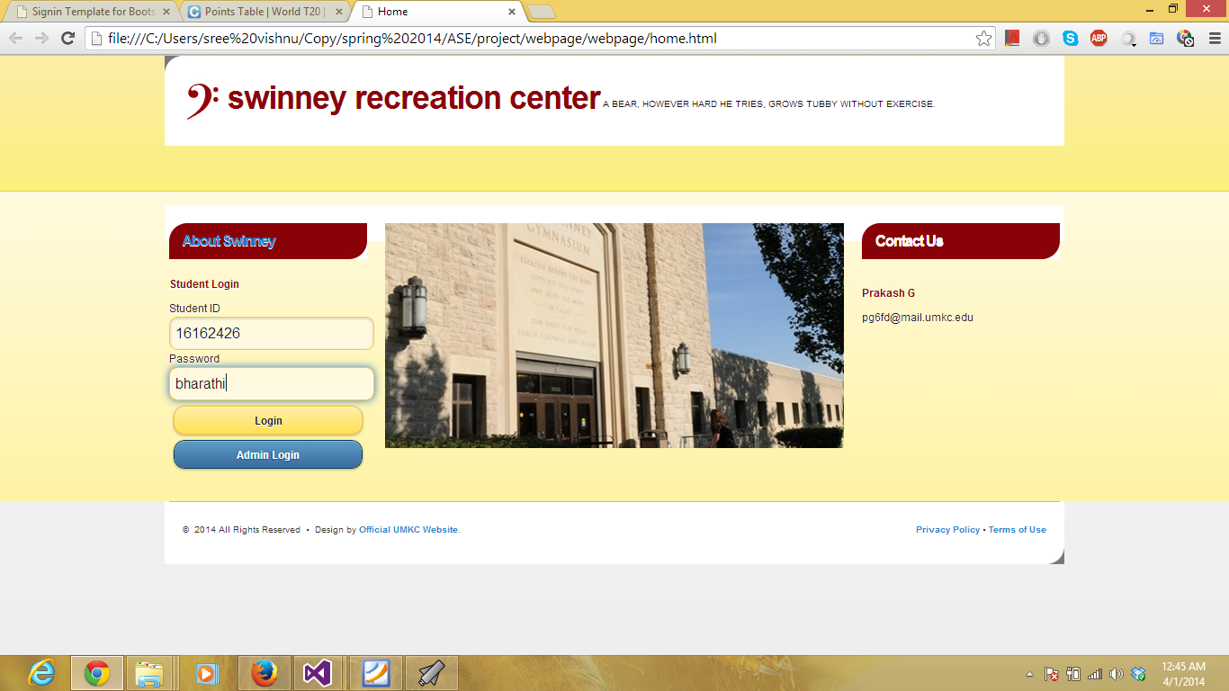

Student Logins in the account.

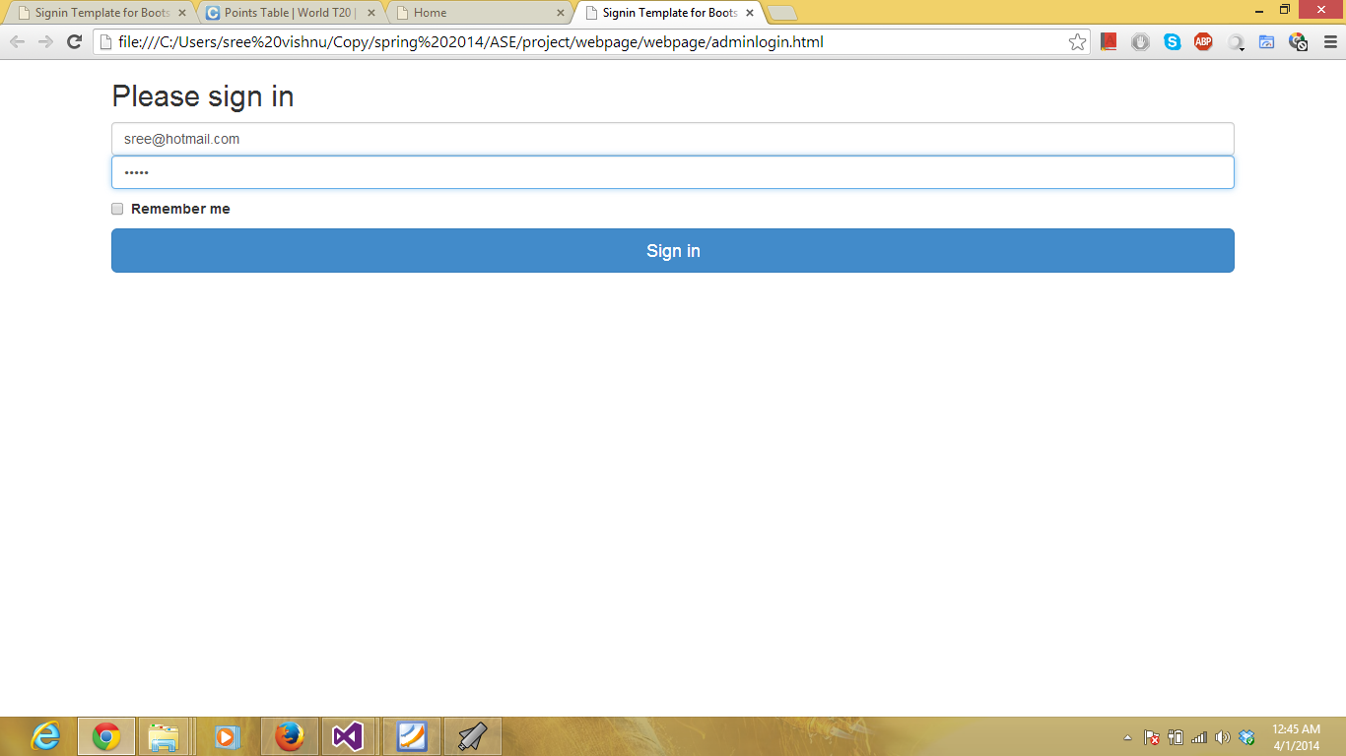

Admin Login is selected and username and password were entered. Admincheck service is consumed now.

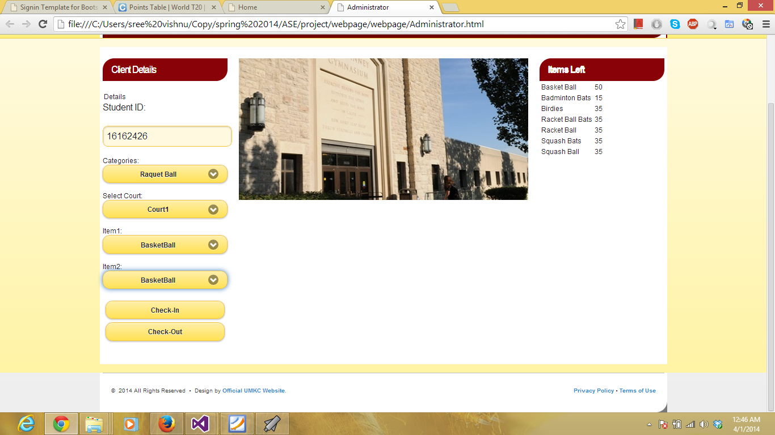

Now the required fields are selected and the data is entered in the fields required. Now the dataenter service is consumed. All the data is stored in the database. From the database the data is retrieved and sent to the user client.

**Third Increment:**

1) This is our home page:



2) When the student logs in with the student details like this 

We will get the following page:

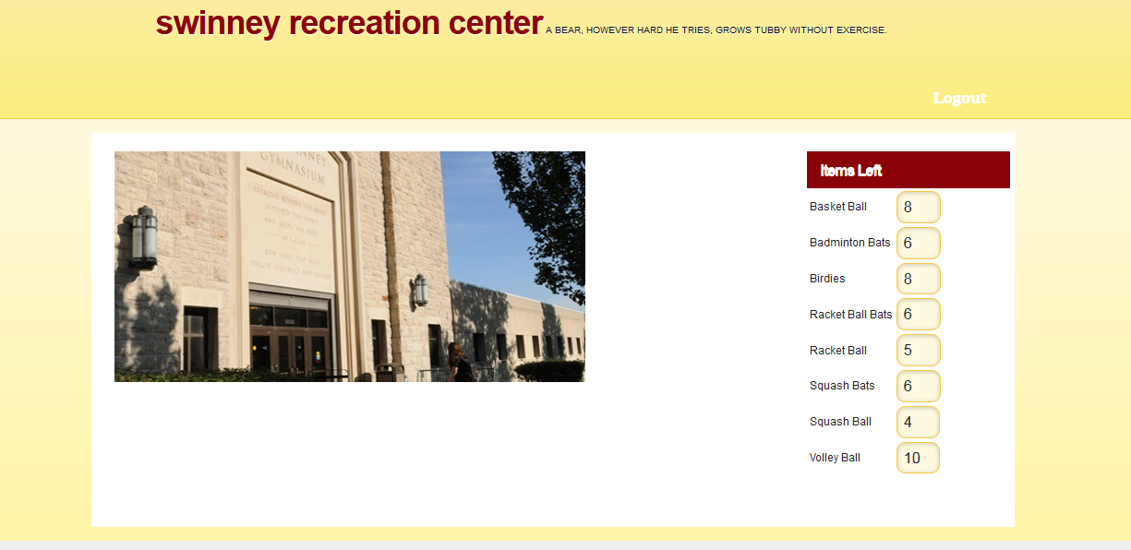

He will get a page where he can see the list of available items.

On seeing the available items he will go to swinney and tell the assistant what all the items he wants. Now the Admin (ie; the person at the desk of swinney) will click on the admin login in the home page.

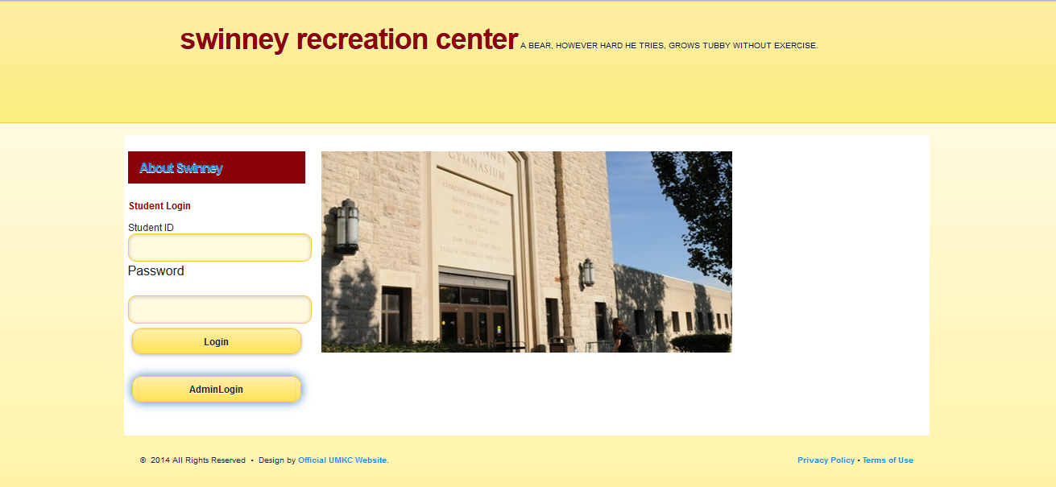

Now he will get this page where he can see the available list and he can enter the details of the student:



Now the admin enters the details of the student and then he checks in



After he checks in then he will get the following screen:



We are currently working on the check-out button. We have written our own web services for Login page and checkin. For the second increment we tried to create with rest web services, but we are getting some errors and we couldn’t implement those services. So, we have shifted to soap services. For the fourth increment we will get the output of checkout button and we will try to improve the student view.

**Fourth Increment:**

**Project**: Our project is Swinney-Gennie which is related to our UMKC swinney. Whenever we go to swinney for playing they will be out of courts or items for playing. We just got idea of this project by this. This project is nothing but when a student logins with his id and password he will get the screen of available items and no of places available in a court. Now he can easily go to swinney whenever the items and courts are available. We have also developed admin side for checking out and checking in what all the items the student has taken.

**Working of our project:**

1) This is our home page:



2) When the student logs in with the student details like this 

We will get the following page:



He will get a page where he can see the list of available items. Here we will also get no of persons in the court ie; total no of persons registered for court. Four persons have to be in a court, so the student can see the availability of the court too. If the court is full he will get an email notification when the court becomes free to the college mail from the admin. The below is the screenshot for that.



On seeing the available items he will go to swinney and tell the assistant what all the items he wants. Now the Admin (ie; the person at the desk of swinney) will click on the admin login in the home page.



Now he will get this page where he can see the available list and he can enter the details of the student:



Now the admin enters the details of the student and then he checks in



After he checks in then he will get the following screen:



When the student comes for the checkout, the admin enters the particular student id of that student and then he clicks checkout.



Now he will get the following screen by checking out all the items taken by that particular id of that student.



When the student or Admin logs out, he will get the following screen ie: home page:

